INTRODUCTION

7PAM2000 Applied Data Science 1

Assignment 3: CLUSTERING AND FILTERING

WORLD BANK DATA ANALYSIS

Name: Abhishek Aeera

Id: 22097107

# WORLD BANK INDICATORS

Climate change is an international issue that cuts beyond national lines and has a wide range of effects on countries. Using publicly available World Bank data, this poster explores a thorough examination of climate change indicators on a national level. The dataset includes a wide range of characteristics, including GDP per capita and greenhouse gas emissions.

In this poster clustering algorithms are used in finding appropriate clusters among the data points. This helps in finding patterns and trends. The main aim of this poster is to have a greater understanding of the intricate interaction between socio-economic determinants and climate change by examining the evolution of indicators over time and concentrating on normalized values.

One of the most urgent issues of our day is global warming, which is mostly caused by human activity such as rising greenhouse gas emissions. The global economy is one of the many aspects of human existence that

* The World Bank's indicators are a broad range of measurements that show many facets of the social, economic, and environmental circumstances of a nation.
* The indicators have been carefully selected and standardized to provide comprehensive studies and cross-national

## DATASET

* + The World Bank, is a popular dataset which contains information about the nations, its financial and technical support for development

are impacted by rising temperatures and changing climatic patterns, which have an influence well beyond

the environment. This investigation aims to comprehend the complex interplay between GDP (gross domestic product) and global warming in various nations. Climate change has a wide range of effects on economies, some of which are already noticeable as warming accelerates. These effects include changes in agricultural production and an increased chance of extreme weather events that can disrupt supply networks. Developing educated policies and initiatives to lessen the effects of climate change requires an analysis of the relationship between GDP and global warming.

The purpose of this study is to use machine learning

comparisons.

* + Some of the common indicators are economic, social, climate change, education, health care indicators etc.
  + It is an open data source from which we can quickly extract any data base.
  + The dataset could be downloaded in csv or

**[4]**

initiatives.

* + This extensive dataset provides a thorough look at the socioeconomic conditions of nations worldwide by encompassing a wide range of indicators from different fields.

## METHODOLOGY

* + K-means clustering and different curve fit is used for fitting the data.
  + Python programming is used for performing the analysis and writing down the code.

so as to present a more complex picture of the relationship between GDP and global warming. The knowledge gathered from this study can improve climate-related risk resilience, guide sustainable development strategies, and open the door to a more robust global economy.

excel format and can be used by many policymakers and analyst in analysing the data.

**ANALYSIS**

* + - By utilizing curve fitting techniques in addition to machine learning clustering algorithms, our goal is to identify patterns, trends, and possible future trajectories that offer important insights into the intricate relationship between economic consequences and global warming.
    - There are three levels of clean fuel access and technological availability in rural regions.
    - There is a direct relation between the imports and GDP in the countries that have higher rural access to fuels. Whereas there is a inverse relation between import and GDP in the countries with medium rural access.
      * The trends that have been noticed point to distinct stages of economic growth that are connected to rural residents' access to technology and fuel. A good trajectory of economic progress is associated with more access, whereas a transitional phase may be indicated by reduced access.
      * Governments may take into account customized plans according to the extent of rural accessibility. Promoting commercial connections may help nations with more access accelerate economic growth. On the other hand, focused initiatives to increase rural access might be given priority in nations with worse access in order to boost GDP growth and imports.

# CONCLUSION

This approach, then, goes beyond a simple data investigation and dives into the complex web of economic growth, providing a prism through which we may understand the different paths taken by different countries. Acknowledging the importance of fuel and technology accessibility in rural areas allows policymakers to create plans that promote sustainable economic growth that are specific to each nation. This study adds to the growing body of knowledge on equitable and resilient economic growth in a global setting, in addition to data-driven decision-making.

**REFERENCES**

1. https://databank.worldbank.org/source/world-development-indicators
2. https://byjus.com/biology/global-warming/
3. https://carnegieendowment.org/2023/01/04/economic-development-in-era-of-climate-change- pub- 88690#:~:text=Climate%20change%20augurs%20a%20fundamental,and%20enable%20them

%20to%20thrive.

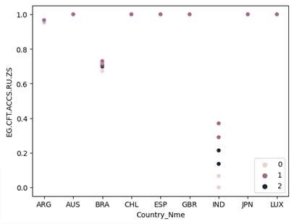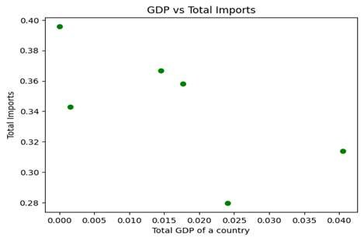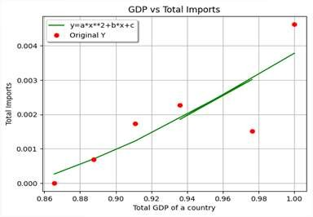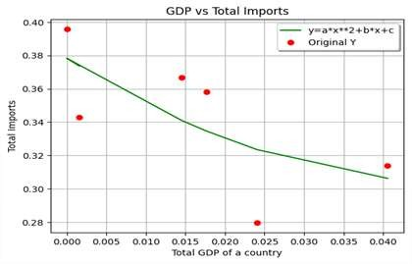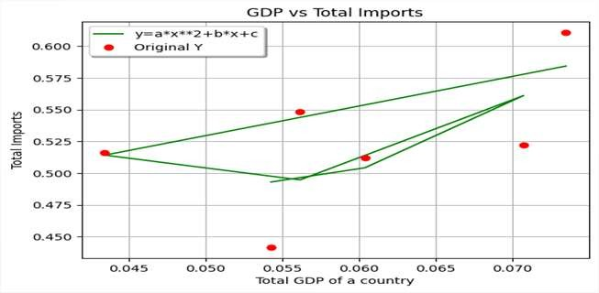

1. https://[www.analyticsvidhya.com/blog/2021/04/k-means-clustering-simplified-in-python/](http://www.analyticsvidhya.com/blog/2021/04/k-means-clustering-simplified-in-python/)